Team Name – Bugminators

Details of all team members –

1. Name – Anshika

Institute Roll No – 12113011

College – National Institute of Technology, Kurukshetra

Gender – Female

Phone No. (WhatsApp) – 8112502264

1. Name – Abhay Rawat

Institute Roll No – 12113063

College – National Institute of Technology, Kurukshetra

Gender – Male

Phone No. (WhatsApp) - 7309254985

1. Name – Aanchal Kapoor

Institute Roll No – 12113069

College – National Institute of Technology, Kurukshetra

Gender – Female

Phone No. (WhatsApp) - 7206899268

Briefly mention details about the following.

**Problem Statement –**

Creating technology solutions to improve patient outcomes - Although the level

of technology in healthcare is at an all-time high, there is still immense potential

to use technology to automate daily operative processes and tasks. The goal is

to develop innovative technology solutions that can improve the quality,

accessibility, and affordability of healthcare for patients. The outcome could be a

set of new and innovative solutions that can be further developed and

implemented to help improve the healthcare system and better serve patients.

**Solution –**

A complete website that will help the patient to get an appointment, reach the doctor, and take medicine on time. It also helps to maintain the history of the patient for future use. Patients just have to use this website for everything from reaching the doctor to the next appointment. It will also show the could be disease and its cure after the patient fills out the form specifying their symptoms.

# It will be helpful for not just the patients but also reduces the workload of the hospitals and clinics and prevent long lines outside clinic and hospitals.

# List the functionalities :

1):1st page will be the login page or registration page which will check whether the user is a patient or a doctor and according to project them to their specific dashboard.

Patients Dashboard:

1): On the patient dashboard there will be a form in which he/she can fill the symptoms they are experiencing at that moment, according to the symptoms a list of doctors will be shown to the patient. Also, a list of could disease and its cure will be shown.

2): Patients can select the slot as per their preferences and they will be notified an hour when their slot will be available, this will prevent long lines outside the clinic.

3): After the appointment, patients can rate the Doctor. Which will help other patients to select the doctor in the future.

4): All the test reports will be saved for further reference this will allow patients to store their health history for later use.

Doctor Dashboard:

1): Details of the Doctor with their specified field will be filled in at the time of the registration.

2): They can fill their available slots and edit them later on.

3): A notification will be received by the Doctor about the patient at that slot.

**Tech stack –**

*Programming languages:- HTML, CSS, JavaScript, Nodejs*

*Frameworks:- Bootstrap, Express, EJS*

*Databases:- MongoDB, Mongoose*

*Technology:- Git, GitHub, Health Care APIs*

# Flowchart:

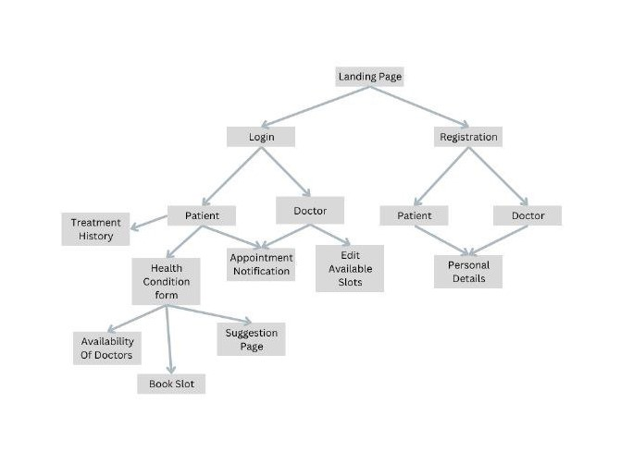

# Use case:

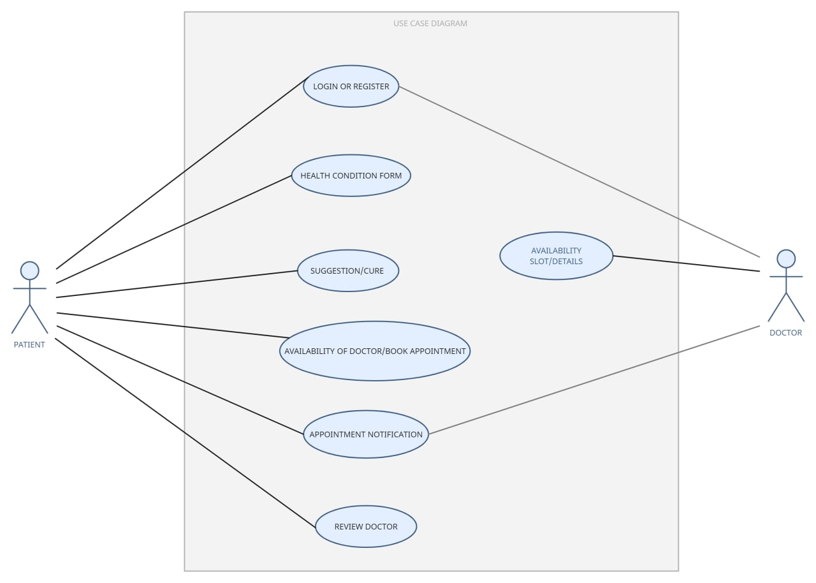

PATIENT:

1. Login or register on the website

2. Fill out a health condition form which includes personal details, details of symptoms, any allergies, medical history, and any chronic illness.

3. A suggestion or a cure will be displayed accordingly.

4. A list of doctors with their time slots will be displayed from which the patient can book a suitable appointment.

5. The patient will be notified an hour before their appointment.

6. The patient can also rate the doctor according to his/her experience.

DOCTOR:

1. Login or register on the website.

2. Enter personal details, specification area, hospital/clinic working in, availability slots, etc.

3. A notification regarding an already booked appointment by a patient.

# Future scope:

1: Patients can pay online through the website itself.

2: The availability of beds in the hospitals will also be featured.

3: After the uploading of the prescription a reminder will be sent to take the specified medicine .

4: the time it will take to reach to the clinic or hospital will also be shown as well the location.